Aseismic slip and seismic swarms leading up to the 2024 M7.3 Hualien earthquake

Kate Huihsuan Chen¹, Wei Peng¹, Roland Bürgmann²
- Dept. of Earth Sciences, National Taiwan Normal Univ., Taiwan
- Berkeley Seismological Laboratory, Department of Earth and Planetary Science, University of California, Berkeley, California, USA

Recognizing the locations and timing of aseismic fault slip during the earthquake cycle may be critical for short-term earthquake forecasting and hazard assessment. Abundant M ≥ 6 earthquakes and widespread aseismic slip in a double-vergence suture in eastern Taiwan provide a rare opportunity to better understand the role of aseismic slip in earthquake cycle deformation and triggering relationships. By tracking aseismic slip captured by repeating earthquake sequences and earthquake swarms in eastern Taiwan from 2000 to mid 2024, we observed an acceleration of aseismic slip rate that occurred approximately three years preceding the April 3, 2024 Mw7.3 Hualien earthquake. The accelerated aseismic slip revealed by the repeating earthquake data was accompanied by a four-month-long active seismic swarm starting on April 18, 2021, in the 2024 Mw7.3 epicentral area. The swarm occurred on the west-dipping Central Range fault exhibited a northward and upward migration pattern with a diffusion rate of ~ 6 m²/s. After 2021 swarm sequence, the regional aseismic slip rate initially decreased until an Mw 6.1 event in June 2022, followed by a gradual increase in the aseismic slip rate leading up to the mainshock over approximately 1.5 years. Concurrent with the accelerated aseismic slip, the Central Range Fault was characterized by a heightened seismicity rate until the 2024 Mw7.3 mainshock. The resulting static Coulomb stress change reveals that accumulated aseismic and seismic slips from swarms, RESs, and M6+ events on the CRF from mid-2021 to mid-2022 generally produce positive stress changes (up to 20 kPa) on the same fault. The sequential seismic-aseismic interplay of faulting in the epicentral area of the 2024 Hualien event provides a rare example of aseismic-slip-induced stress triggering leading up to the 2024 Mw7.3 earthquake.
You can make paragraphs and use equations. Please indicate the presenting author by an underline below his/her name. Please don’t change the heights of the header and the footer of this template.

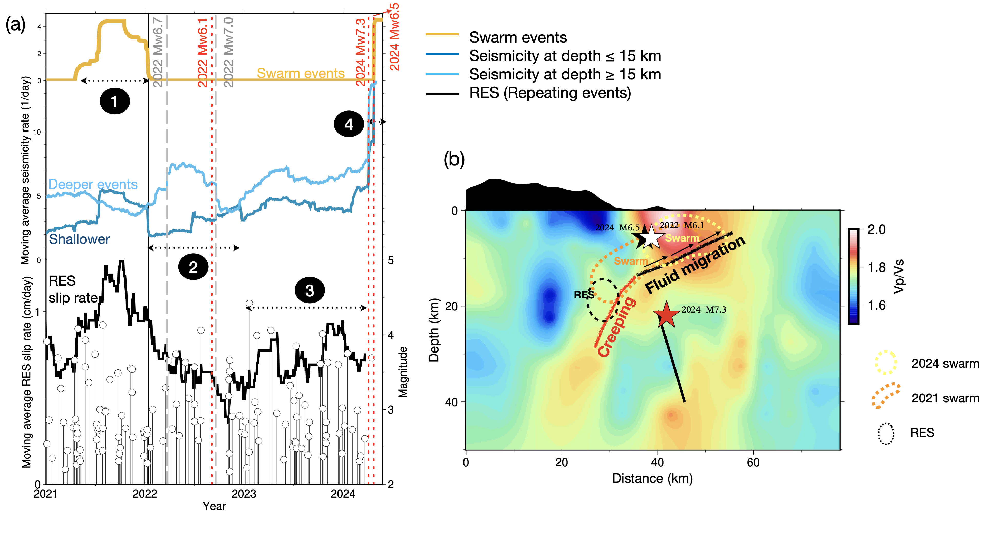
Figure 1. (a) Top: temporal distribution of earthquake swarm events (yellow curve). Center: shallow seismicity (light blue curve < 15 km) and deep seismicity (dark blue curve > 15 km). Bottom: aseismic slip rate (black curve) and RES events (vertical bars). All time series are from events in the epicenteral area of the 2024 M7.3 mainshock. Vertical red dashed lines indicate the times of three M6+ events during this period. Vertical gray dashed lines indicate the times of two M6+ events occurred on the south LV area. The vertical black line marks the end of the 2021 swarm. Numbered dashed lines denote different stages of seismic and aseismic slip behavior. (b) Conceptual model for the interplay between seismic and aseismic slip after 2021. Yellow and orange dashed lines outline the distribution of the 2021 and 2024 swarms, respectively, while the black dashed line outlines the distribution of the RESs. The fluid migration pattern during the 2021 swarm is denoted by arrows. The background color indicates the Vp/Vs ratio from Huang et al. (2014).

References
Huang H-H, Wu Y-M, Song X, Chang C-H, Lee S-J, Chang T-M, Hsieh H-H (2014) Joint Vp and Vs tomography of Taiwan: implications for subduction-collision orogeny. Earth Planet Sci Lett 392:177–191

